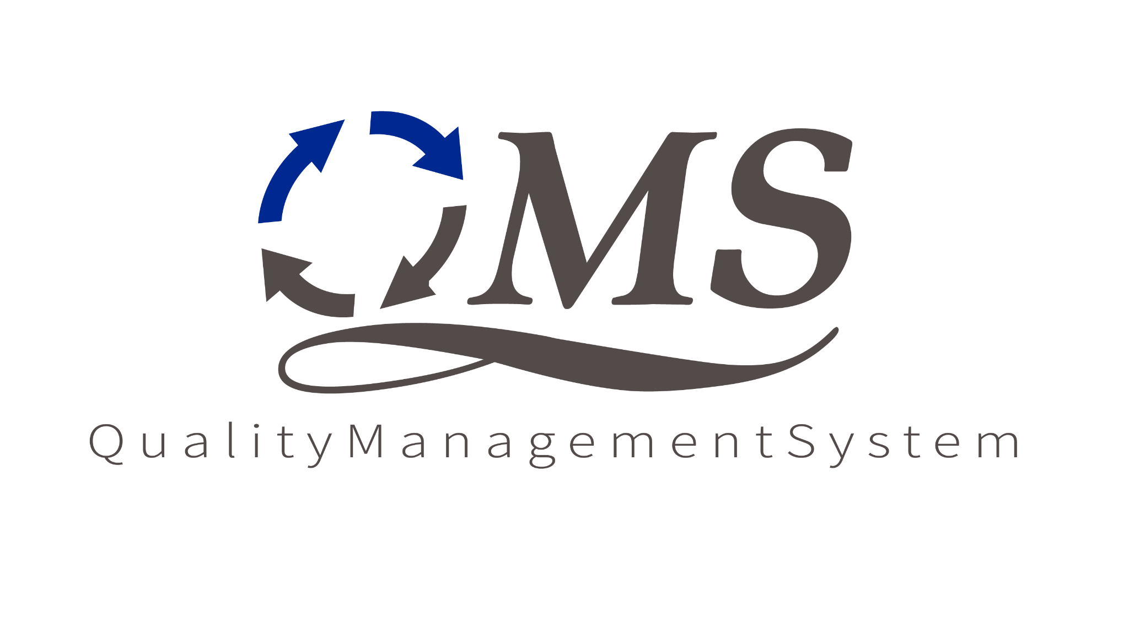

**Software Maintenance Process**

**Version 1.7**

**Document Version History**

| **Version Number** | **Revision Date** | **Summary of Changes** | **Modified by** | **Approved by** | **Approval Date** |
| --- | --- | --- | --- | --- | --- |
| 1.0 | 05/03/2019 | Initial release | Rizwan Habib; Jake Vose | Claude Shacklett | 05/07/2019 |
| 1.1 | 03/26/2020 | Document updated; acronyms added | Shreyasi Rudra | Claude Shacklett | 03/26/2020 |
| 1.2 | 08/21/2020 | Edited document; added Confidentiality Statement and Legal Disclaimer | Dayo Akinwande | Larissa Khon | 09/29/2020 |
| 1.3 | 02/25/2021 | Annual review 2021 | Claude Shacklett | CPG | 02/26/2021 |
| 1.4 | 05/27/2021 | Updated QMS Logo | Shreyasi Rudra | CPG |  |
| 1.5 | 04/14/2022 | Annual Review 2022 | Claude Shacklett | CPG | 04/14/2022 |
| 1.6 | 02/06/2023 | Annual Review 2023 | Juan Alvarado | CPG | 02/06/2023 |
| 1.7 | 05/06/2024 | Annual Review 2024 | Claude Shacklett | CPG | 5/06/2024 |

**Table of Contents**

**CONFIDENTIALITY STATEMENT AND LEGAL DISCLAIMER** **4**

**1. Objective** **5**

**2. Scope** **5**

**3. Acronyms and Definitions** **5**

**4. Entry Criteria** **6**

**5. Inputs** **6**

**6. Process Description** **6**

**7. Outputs** **9**

**8. Exit Criteria** **10**

**9. Roles and Responsibilities** **10**

# 

# CONFIDENTIALITY STATEMENT AND LEGAL DISCLAIMER

The information contained in this document is confidential, privileged, and only for the information of the intended recipient and may not be used, published, or redistributed without the prior written consent from CTAC. If you are not the intended recipient, you may not disclose or use the information in this document in any way. Any review, retransmission, dissemination, or other use of, or taking any action in reliance upon this information by persons or entities other than the intended recipient is prohibited. If you got access or received this document in error, please contact the owner and delete the document from all electronic devices.

# 

# 1. Objective

The objective of the Software Maintenance process is to identify, analyze, and validate the maintenance requirements. Such requirements are converted to design, source code and integrate the code components, verify and validate the deliverables, and ensure all the deliverables are successfully delivered.

# 2. Scope

The Process is applicable to all software maintenance projects that are executed at CTAC. The scope of activities are:

* Receiving an Issue/Change from customer
* Issue logging and classification
* Analysis and design
* Development
* Testing
* Delivery
* Acceptance testing

# 3. Acronyms and Definitions

| **Acronym/Abbreviation** | **Description** |
| --- | --- |
| TL | Tech Lead |
| PM | Project Manager |
| BA | Business Analyst |
| SA | System Administrator |
| PQA | Process Quality Analyst |
| REV | Review Team |
| DEV | Development Team |
| TE | Test Engineer |
| TT | Testing Team |
| TW | Technical Writer |
| CC | Configuration Control |
| UXD | User Experience Designer |

# 4. Entry Criteria

* Kick-off meeting
* Support team identified as per required skills

# 5. Inputs

* Statement of Work/Contract/Work Order
* Software technical documents and standards

# 6. Process Description

The major steps in this process are as follows:

* Planning for software and/or infrastructure maintenance
* Issue logging
* Issue analysis and development
* Issue Resolution

| **SN** | **Description** | **Record/**  **Process Artifact** | **Responsibility** |
| --- | --- | --- | --- |
| **Maintenance Transition** | | | |
| 1 | Understand the maintenance requirements including service levels and service requirements; initiate the transition and conduct kick-off meeting | Project Management Plan | PM/BA//TL |
| **Project Management** | | | |
| 2 | Plan for process & product, data management, configuration management, metrics, quality, risks, stakeholder commitment, monitoring & control, escalation, decision analysis & resolution, make/buy/reuse analysis, etc. | Project Management Plan | PM/BA/TL |
| 3 | Establish maintenance project environments (development & test) based on the Project Management Plan | Project Management Plan | PM/TL |
| **Issue Logging** | | | |
| 4 | Receive the issue from the customer based on the agreed communication mode/channel | Email, document, issue tracker | PM/BA |
| 5 | Log the issue in Maintenance Tracker assigning Issue ID and other details as per the tracker | Issue Tracker | PM/BA |
| **Issue Analysis & Development** | | | |
| 6 | Analyze if the issue is a defect or a change | Issue Tracker | PM/BA/TL |
| 7 | If the issue is a change, log the change in Issue/Change Log | Issue Tracker | PM/BA/TL |
| 8 | Raise questions and seek clarifications if any | Issue Tracker | PM/BA/TL |
| 9 | Identify the severity of the issue | Issue Tracker | PM/BA/TL |
| 10 | Conduct impact analysis of the issue/change and prioritize accordingly | Issue Tracker | PM/BA/TL |
| 11 | Respond to the customer on the issue based on the impact analysis | Issue Tracker | PM/BA/TL |
| 12 | Assign the issue to the development team | Issue Tracker | PM/BA/TL |
| 13 | Fix the issue and conduct testing to ensure that the issue is fixed | Test Report | DEV |
| 14 | Deliver the patch to the customer based on the naming conventions and agreed delivery mode. | Delivery Note | PM/TL |
| **In Case of a New Requirement/Change** | | | |
| 15 | Log the new requirement/change raised by the customer in the issue tracker. | Issue Tracker | PM/BA/TL/DEV/ SA/Customer |
| 19 | Review and approve an impact analysis for new requirements/change | Issue Tracker | PM |
| 20 | Assign the change to Development and/or System Administration Team. | Issue Tracker | PM/BA/TL |
| 21 | Implement the change and conduct testing to ensure completeness | Test Report | DEV/TE |
| 22 | Deliver to the customer | Release Note | PM/BA/TL |
| **Issue Resolution** | | | |
| 23 | Get confirmation from the customer related to the closure of the issue(s) | UAT | PM/BA/CUS |
| 24 | Update the Issue Status and Closure Date/Time in the Maintenance Tracker as Closed based on the confirmation from the customer. | Issue Tracker | PM/BA/TL |
| **PQA Review** | | | |
| 25 | Conduct a PQA audit of maintenance and report quality issues | Audit Report | PM/BA/DEV/PQA |
| 26 | Analyze and release quality issues | Audit NC Tracker | PM/BA/PQA |

**7. Permitted Tailoring**

# Refer [Tailoring Guidelines](https://docs.google.com/document/d/1zgUhPRrt5T2k56NzlGZHoQc9fsef6ciBE_TPln0nVRI/edit?usp=sharing)

# 8. Outputs

* Project Management Plan
* Software Release Notes
* DAR Plan
* Test Plan
* Issue Tracker Review
* Configuration Audit Report
* Release Notes
* PQA Audit Report

# 9. Exit Criteria

* PQA Approved Project Management Plan
* PQA Approved Software Release Notes
* PQA Approved Test Plan
* Approved Changes
* Customer Sign Off
* Closure of all the PQA audit findings for the maintenance phase

# 10. Roles and Responsibilities

| **Role\*** | **Responsibility** |
| --- | --- |
| Program Manager | * Assign Project Manager/Team Lead for the project * Review project status periodically * Resolve project issues that are escalated * Ensure resource availability for identified and planned resource needs * Ensure QMS implementation in a project or group of projects defining an engineering group |
| Project Manager | * Reviews and approves Project Management Plan * Negotiate with the customer if customer issues a change request * Assigns/plays the role of Change Authority for the project * Plan and conduct internal acceptance tests and certifies deliverables * Assist customers as required in implementation planning and user training * Ensure the resolution of post-project quality problems, if any * Identify, plan and meet training requirements of personnel in the group with the help of the training group * Ensure that staff in the group is trained in QMS * Assign resources required * Monitor project progress * Forms an integrated project team as per the guidelines in QMS and Heads the team * Assign roles and responsibilities of the team * Monitors and tracks the project progress along with the team * Determine and plan any required training * Responsible for the overall project requirements * Ensures that the goals of the project management plan are met * Ensures that acceptance tests are developed to validate the product * To ensure that the developed product aligns with product backlog and fits the intended client requirement * Review and approve the backlog for each planned iteration * Plan and schedule activities including backlog grooming * Monitor and control the project progress along with the team on a daily basis * Monitor and report project status to stakeholders * Identify and manage issues to closure * Identify risks and develop mitigation plans respectively create the Configuration Library and manage it for the project * Record configuration information * Record and manage changes |
| Business Analyst | * Ensure that those configuration items are controlled as per the Project Management Plan * Create and review of all reporting deliverables * Report on the project status to the Project Lead on a periodic basis * Monitor project progress * Project/Software Maintenance Release * Provide day-to-day maintenance support for consistent performance of the software * Maintain feedback and correspondence from clients * Coordinate with support groups |
| Quality Management Plan | * Review and approve the project management plan * Advise Tech Lead and Project Manager on adherence to project process and quality objectives * Facilitate the project team in implementing the defined process * Conduct work products audits * Participate in project review, end phase meetings, etc. * Analyze project metrics along with CPG |
| Test Engineer | * Plan and coordinate all testing activities * Participate in project meetings * Develop test plans and test cases * Resolve any issues between the testing team and the rest of the project team * Receive training on the required areas * Undertake and report back on activities allocated by the Test Lead * Participate in project meetings * Review Test Cases and Test Results where applicable * Prepare/consolidate Test Report based on test results where applicable |
| Change Authority | * Authorize and approve changes |
| SA | * Attend to customer support requests * Identify solution and resolve issues * Undertake and report back on activities allocated by the Tech Lead * Provide root cause analysis for infrastructure outages |